1. [GEO.ca](https://geo.ca/home/index.html)
2. Initiatives
3. CGDI
4. ArcticSDI

# Arctic Spatial Data Infrastructure (Arctic SDI)

The Arctic SDI is a collaborative partner-based effort of the National Mapping Agencies of the Arctic.

## On This Page

1. About Arctic SDI
2. Arctic SDI Geoportal
3. Arctic SDI Services
4. Resources

## About Arctic SDI

Think of the [Arctic Spatial Data Infrastructure (SDI](https://arctic-sdi.org/)) as a highly specialized global information highway. It provides a framework where users can connect to geographic data from numerous sources to create a sum that is the greater than the parts. This resource allows diverse data to flow worldwide and to be combined and analyzed across nations, communities and agencies. Common standards enable users to share and integrate layers of data and information like place names, topography, rivers and lakes, land cover, permafrost and biodiversity.

The Arctic SDI was developed by the National Mapping Agencies of the [Arctic Council](https://arctic-council.org/) member states, including Canada, through Natural Resources Canada’s (NRCan) Canada Centre for Mapping and Earth Observation (CCMEO). It is an example of scientific diplomacy and technical collaboration that continues to support Arctic Council priorities related to climate change and sustainable development. It also supports Indigenous and community resiliency projects, enabling forecasting, monitoring, mitigation and management of climate change impacts.

[transcript]

## Arctic SDI Geoportal

The Arctic SDI provides the connectivity needed to power and deliver data and maps via an online portal. The [Arctic SDI Geoportal](https://geoportal.arctic-sdi.org/) is the access point that allows users to combine data from many different sources, create customized thematic and statistical maps and share these on their own websites as digital, interactive and embedded maps. The Geoportal also provides access to a place name search tool with three million Arctic place names.

[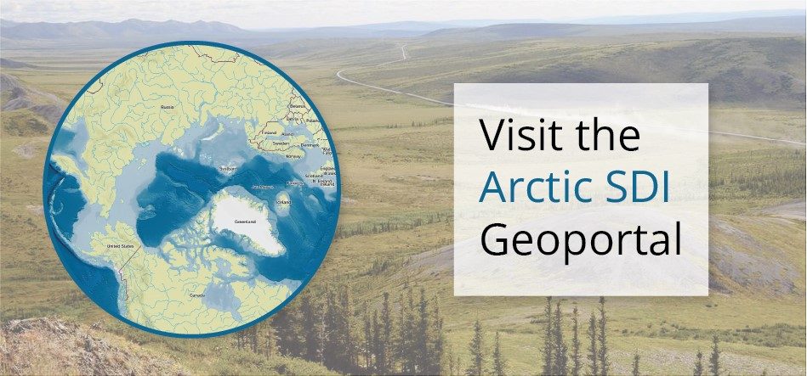](https://geoportal.arctic-sdi.org/)

### Embedded maps

The custom map below is being delivered via the Arctic SDI Geoportal. You can create dynamic interactive maps, known as embedded maps, for delivery via your website without any coding and in just a few quick steps.

#### Permafrost Extent in the Arctic (1993)

The map shows the [permafrost](https://natural-resources.canada.ca/environment/science/indicators-change/permafrost/11011) extent in the Arctic which is currently being impacted by the effects of Climate Change. For example, melting permafrost that heaves buildings and roads while also releasing stores of methane gas that have been locked up for thousands of years.

[Create your own Arctic SDI maps](https://arctic-sdi.org/map-gallery/)

## Arctic SDI services

Access the main web services from ArcticSDI, including the basemap, a geolocator, and the metadata catalogue to find arctic data sources.

|  |  |  |
| --- | --- | --- |
| [Arctic SDI Topographic Basemap](https://arctic-sdi.org/services/topografic-basemap/)  Reference basemap for the Arctic enabling users to display their data in applications such as websites. | [Arctic SDI Gazetteer Service](https://arctic-sdi.org/services/gazetteer-service-search-for-locations/)  Detailed place name information collected from the countries in the Arctic region. | [Arctic SDI Metadata Catalogue](https://arctic-sdi.org/arctic-sdi-metadata-catalogue/)  A catalogue application of metadata records of spatially referenced datasets related to the Arctic region. |

## Resources

Find key links, reports and resources to learn about the Arctic SDI.

|  |  |  |
| --- | --- | --- |
| Photo 2021-657: Caswell Tower, Gascoyne Inlet, NU.[Arctic SDI](https://arctic-sdi.org/)  Visit the Arctic SDI website to learn more about this collaborative initiative of various national mapping agencies. | A map of the arctic  Description automatically generated  [Arctic SDI Geoportal](https://geoportal.arctic-sdi.org/)  View data from many sources, combine layers, and create custom maps of the Arctic in this interactive mapping application. | Photo 2022-438: High-slope, 47 metre high Ibyuk pingo (foreground) and Split pingo (in distance) near Tuktoyaktuk  [Arctic SDI Evaluation Framework](https://natural-resources.canada.ca/sites/nrcan/files/earth-sciences/files/pdf/Arctic%20SDI%20Evaluation%20Framework.pdf)  The Framework (2017) assists in establishing how the Arctic SDI facilitates interoperability of arctic geospatial information. |
| Photo 2014-233: Looking southwest across the Eagle Plain at rounded grey knolls of oil and gas-rich Canol Formation on the west-facing slope of the Richardson Mountains, northern Yukon.[Spatial Data Infrastructure (SDI) Manual for the Arctic](https://geoscan.nrcan.gc.ca/starweb/geoscan/servlet.starweb?path=geoscan/fulle.web&search1=R=305329)  Learn the details of the Arctic SDI with guidance on information management practices. | Photo 2021-672: Aerial view of mountain range and glaciers en route to Eureka weather station, Ellesmere Island, Nunavut.  Arctic SDI Strategic [Documents](https://arctic-sdi.org/documents/strategic-documents/)  Visit the Arctic SDI website for biennial reports, factsheets, governing documents, user needs assessment and more. | The Arctic SDI brings together mapping agencies from eight countries: Canada, Denmark, Finland, Iceland, Norway, Russia, Sweden and the United States.  [Simply Science Article](https://natural-resources.canada.ca/simply-science/global-information-highway-meet-the-challenges-fragile-arctic-ecosystem/22547)  A global information highway to meet the challenges of a fragile Arctic ecosystem. Learn more about the Arctic in this Simply Science article. |