- Geo.ca

GEO.ca is the definitive source for Canada’s open geospatial information.
Open data. Applications. Maps. And more. Discover it all on GEO.ca, along with the tools you need to visualize, analyze and share the insights you create. Unlock the power of location here.
- Datasets
- Contributors

In the Spotlight
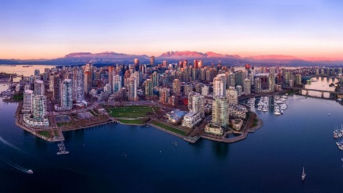  Flood Mapping  Canadian federal, provincial and territorial government geospatial data providers collaborate to provide tools and resources to help Canadians plan and prepare for floods. | 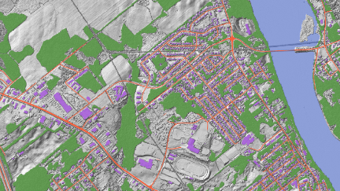  GeoAI  Discover the GeoAI Data Series, the time enabled geospatial features created using artificial intelligence (AI). | 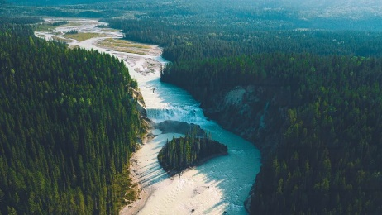  Canadian Hydrospatial Network  Discover Canada’s new, higher-resolution hydrographic network. The Canadian Hydrospatial Network (CHN) data enables the modelling of surface water flow in Canada.

Read more GEO news

Initiatives
  Maps for HTML  Learn how to use and contribute to a standard for simple, accessible, and programmable web maps. | 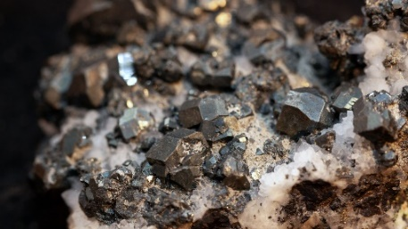Critical Minerals  Discover tools and resources to help strengthen the supply chains of critical minerals. | 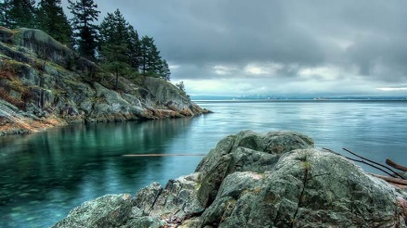  GeoBase Initiative  The GeoBase initiative provides access to, national geospatial foundational data for Canada’s land, water, and infrastructure.

Find more initiatives

Foundation Data
Foundation data represents the core features of Canada’s land, water and infrastructure. Discover them here.
  Federal Electoral Districts - Canada 2019 | 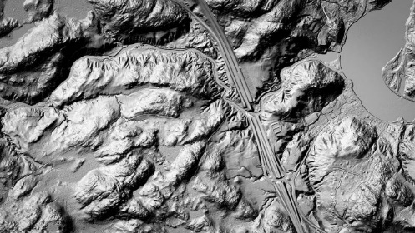  High Resolution Digital Elevation Model Mosaic (HRDEM Mosaic) — CanElevation Series | 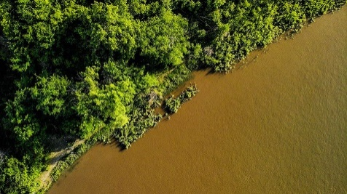  Floods in Canada — Cartographic Product Collection
Find More Foundation Data

Map Gallery
Explore our extensive map gallery. See what’s possible. Reuse what’s already been created. Get inspired. Create and share your own custom map!
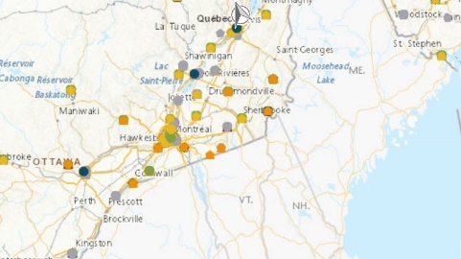  Air Pollutants at Monitoring Stations  VIEW MAP | 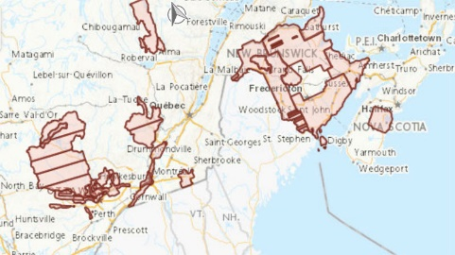  Automatically Extracted Buildings  VIEW MAP | 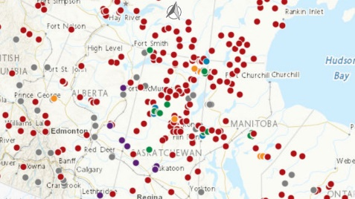  Canada’s Commemorative Map  VIEW MAP
Explore More Maps

