ESP32 Camera Module issue

***Serial output when connected via mobile hotspot***

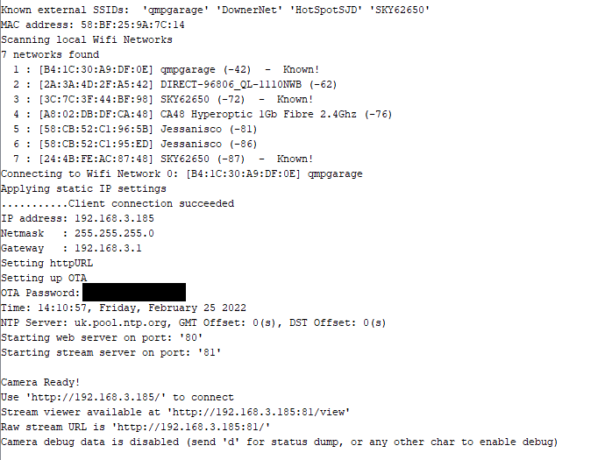

***Serial output when connected to home wifi***

