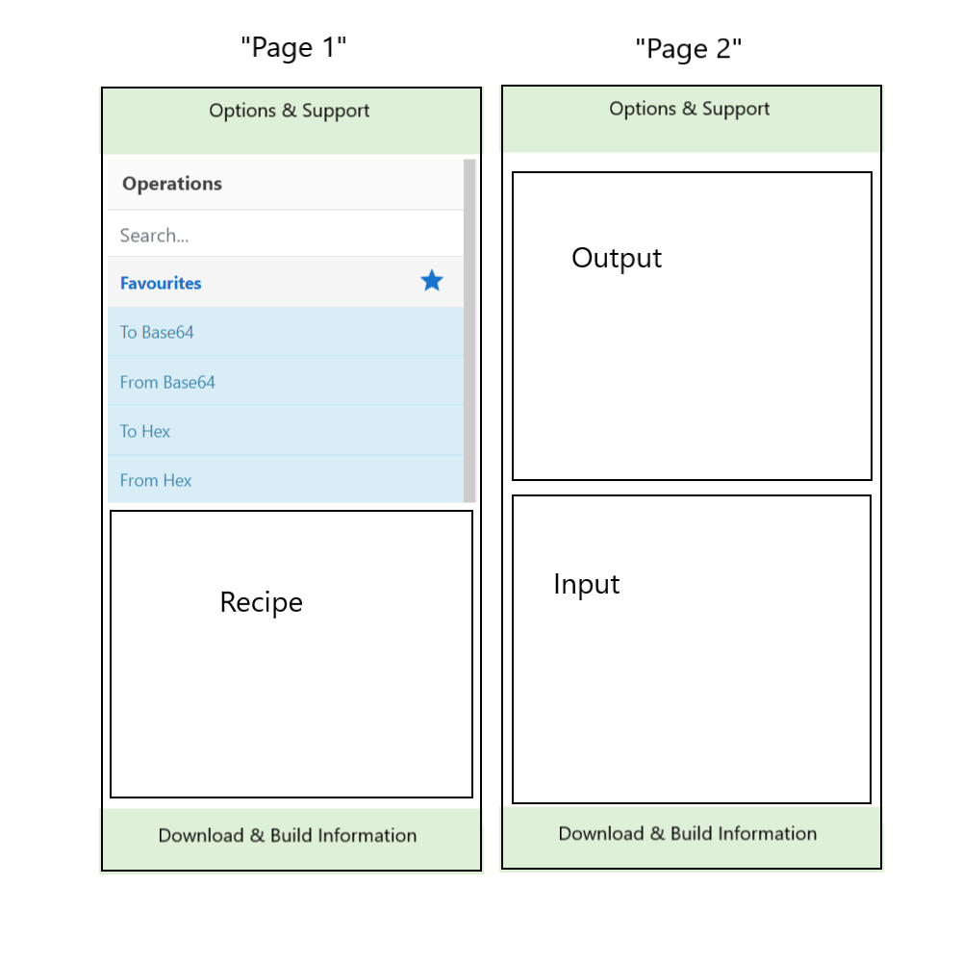

Notes:

* There is a third possible screen configuration 🡪 Recipe & Output (for walkthroughs of recipes
* The addition of a scroll-bar to recipe will need to be handled (should be minor changes from current configuration
* Overflow-y of both recipe and operations will need to be handled
* Options and support will remain fixed at top of page, & download and build info at bottom
  + Build info shortened to “Last build: _ days ago – v_”
* Options page will also need proper resizing