Batch Builder version 2.4.X  
Installation Note for Mac Users

Check to see if python is already installed by typing this at the Mac command line:

python --version

If [installed, nothing else is needed. Python 2.7 will work. You may choose to upgrade to Python 3.

If you get a ‘command not found error’ after checking for Python:

1. Check to see if Python 3 is installed by typing:

python3 –version

1. If installed, symlink python to python3 using this command:

sudo ln -s /usr/local/bin/python3 /usr/local/bin/python

1. Verify that the symlink command worked by checking the Python version again:

python --version

If no version of python is installed:

1. Download and install the latest stable Mac Python release from:

<https://www.python.org/downloads/macos/>

1. After installation is complete, symlink python to python3 by using this command:

sudo ln -s /usr/local/bin/python3 /usr/local/bin/python

1. Verify that symlink worked by checking the Python version again:

python --version

8/9/2022

Quick note on installing BB 2.3.0 and running it on Mac. The latest Mac OS with security restrictions may present some additional security barriers to running Batch Builder successfully. Try the following steps to get v2.3.0 running on your Mac.

To start new BB, first you need to Ctrl Click (or right click) on BatchBuilder.command, so it gives an option to run it even though it is not downloaded from Mac AppStore – the message says “this application is from an unidentified developer”. You will get a message:

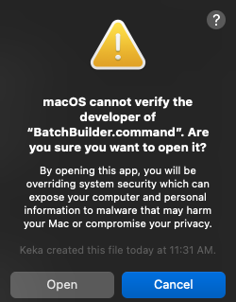

Click Open. Then you’ll get a message:

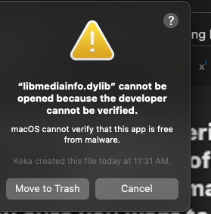

Neither option is good. You need to go to Mac System Preferences – Security & Privacy – General. Then click the lock to make changes. Then click the Cancel in the dialog box above. The name of the libmediainfo.dylib library will show up right under App Store and identified developers. Click on Allow Anyway. Then close BB and restart again.

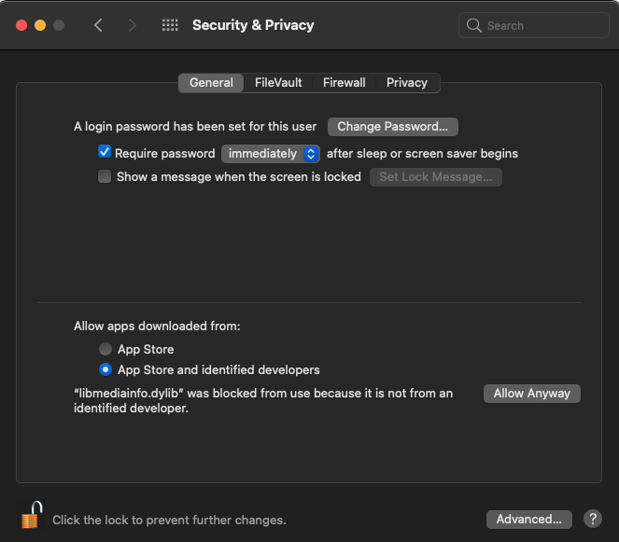

Then, once BB starts loading you will get a new dialog that this time allows you to click Open:

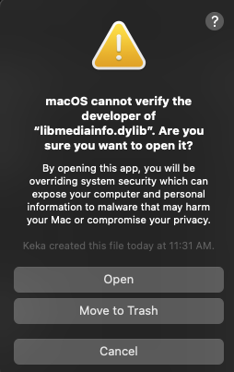

Now you are finally running BB with all the needed components.