Need a way to show different Checkbox status when one of the children is not selected

In the below screen shot at root level if any of the child id not selected then it shows different checkbox icon.

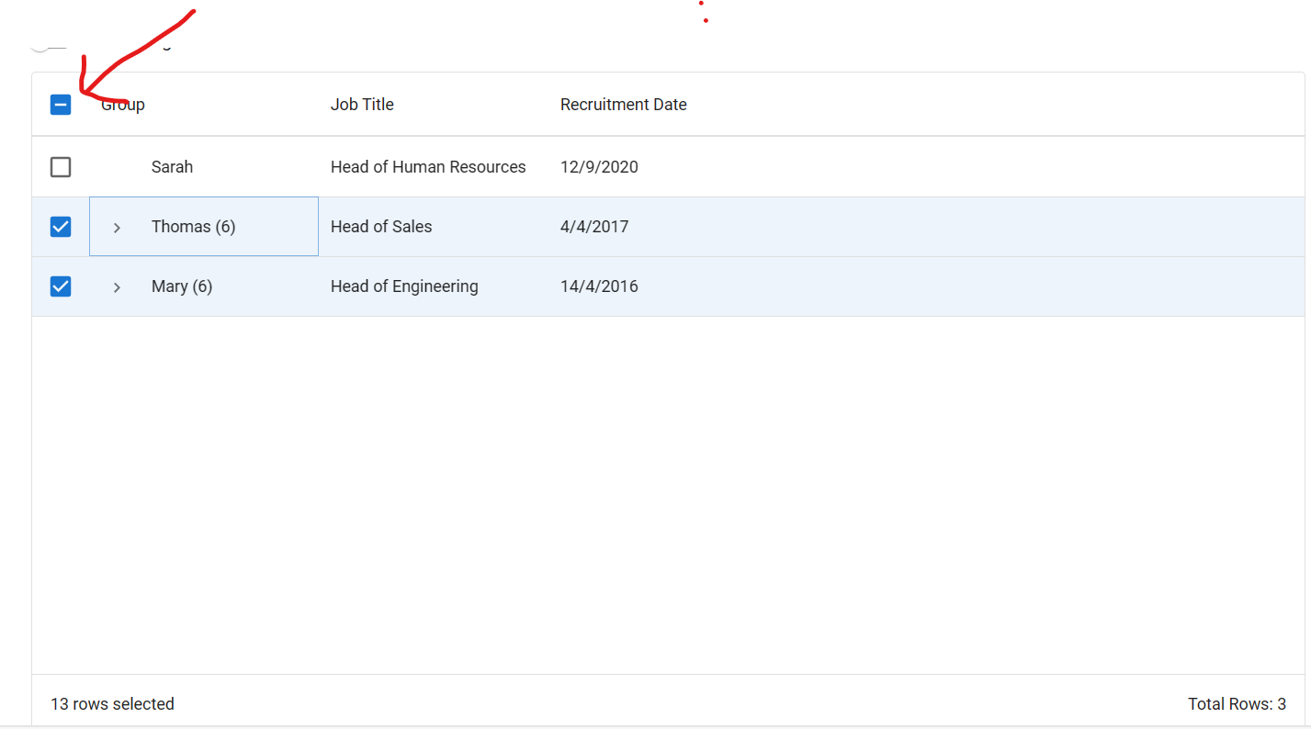

Now if I expand any item and if all items are not selected I want to show similar icon as of above rather then the current behaviour, see below screen shot for current behaviour

