## 1.1 Internal Message Details

|  |  |
| --- | --- |
| Internal Message: |  |
| Test Plan: | ACC SAP Kyma runtime 2024 |
| Message Priority: | Medium |
| Affected UI | Input field, List box |
| Affected Check Point: | [ACC-264.1](https://wiki.one.int.sap/wiki/display/Acc/ACC-253+Details#ACC253Details-legal) |
| Short text: | ACC-264.1 (Level A) _Input field, List box_ Associated labels are not announced |

## 1.2 Application Details

|  |  |
| --- | --- |
| Application Name | Kyma-dashboard |
| Technology: | SAP UI5 |
| Component: |  |
| URL: | <https://dashboard.stage.kyma.cloud.sap/cluster/garden-kyma-stage--c-7074971-external/kymamodules> |
| Username/Password: | NA |

## 1.3 Test Environment Details

|  |  |
| --- | --- |
| Web browser: | Google Chrome Version 127.0.6533.89 |
| Operating System: | Microsoft Windows 11 x64 |
| Screen Reader: | JAWS 2024 Version 2024.2406.121 ILM |

**1.4 JIRA/SNOW Details**

|  |  |
| --- | --- |
| Issue: | Bug |
| Labels: | Accessibility |

**2 Screen Flow**

* Launch the application using given URL.
* Select the ‘Link to Kyma dashboard’ from the Kyma Environment section on your SAP BTP subaccount page.
* Go to KubeconfigURL:https://kyma-env-broker.cp.stage.kyma.cloud.sap/kubeconfig/DFEFE4E0-E202-4455-8A61-37511B4D7553
* Click on the link https://dashboard.stage.kyma.cloud.sap/clusters and select Connect.
* Upload the kubeconfing file downloaded in the first step. You can either drag and drop it or select the upload icon to choose it from the device.
* Next Step

**3. Issue Type: Manual**

**Observed Behavior:**

On accessing the ‘Input fields’ and ‘List box’, The associated labels such as ‘ Name’ , Authentication type’ , Issue URL’ , Client ID’ , ‘Client Secret’ and ‘Scopes’ are not read out.

**Screenshot:**

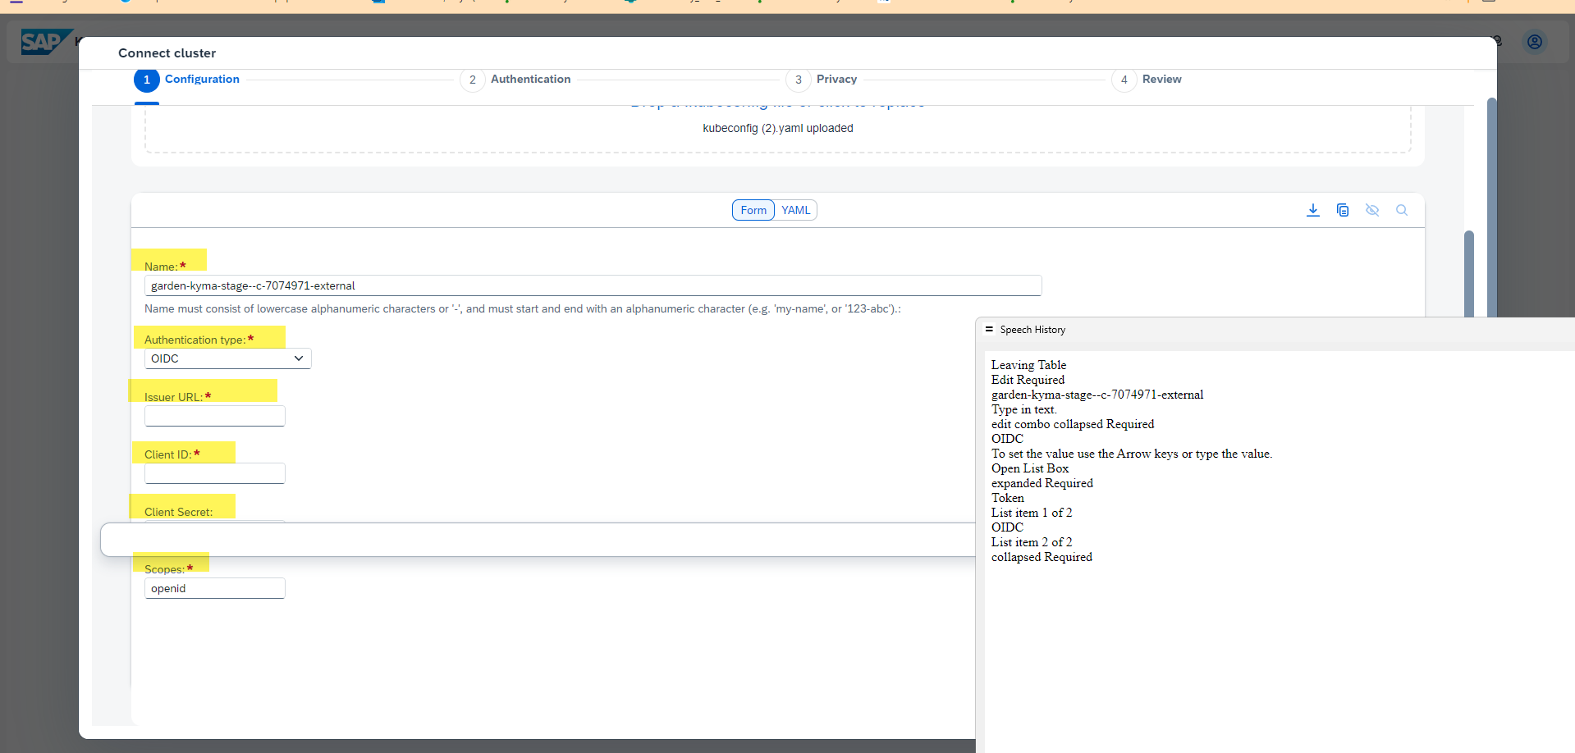

**Expected Behavior:**

Only relevant information about the UI should be communicated to the user. Additional information should be avoided.