Testing of 10923

Reproducing Issue in internal with dev build:

Uploaded [toolsfairy-audio.zip](https://github.com/user-attachments/files/17361796/toolsfairy-audio.zip) to dataset

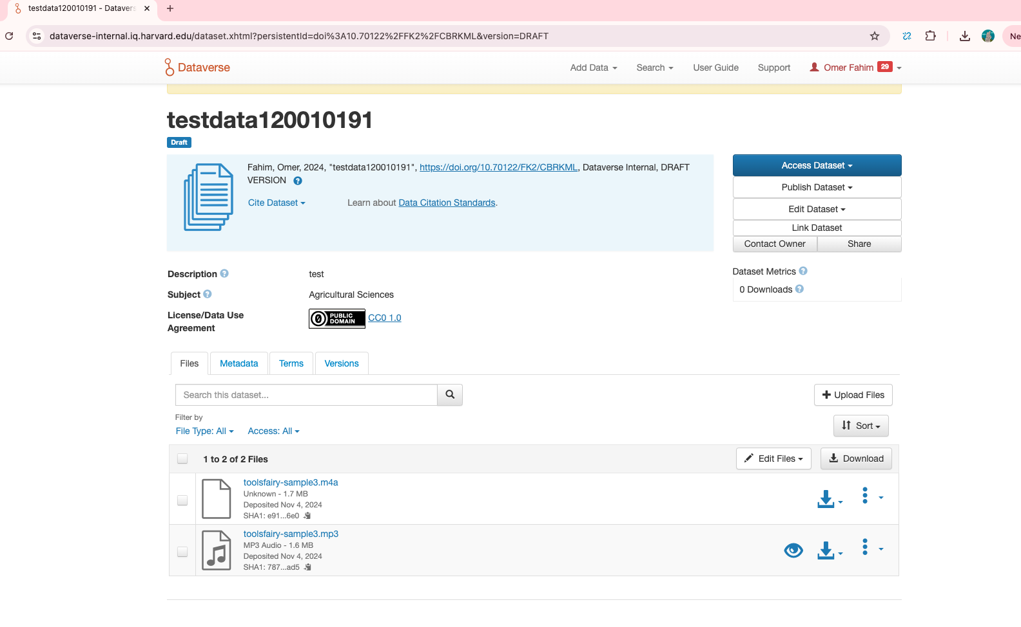

The file should get contentType audio/x-m4a like when uploading the individual files with chrome

Testing with Fix in local

Can now see MPEG-4 Audio under file name

Regression Testing:

Create Dataset with different types of file types

