**Subject:** tooltips - popovers - dialogs

**Status:** Not Started

**Percent Complete:** 0%

**Total Work:** 0 hours

**Actual Work:** 0 hours

**Owner:** Schnabel, Stefan

Tooltip role + pattern

* <https://www.w3.org/TR/wai-aria-1.2/#tooltip>
* <https://www.w3.org/WAI/ARIA/apg/patterns/tooltip/>

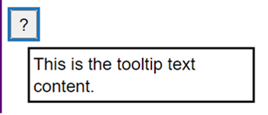

Visual / IXD Designer: Damn. Can’t we at least have links as parts of tooltips ? Its so easy you just hover,. Click and you are there.   
(And designs it, unknown developer implements it)

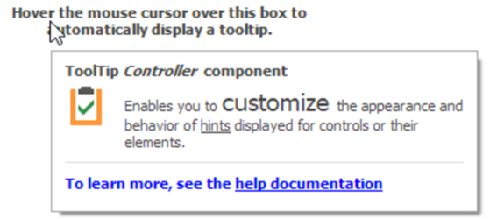

Accessibility tester refuses to accept:

* Current ARIA spec says NO according to allowed tooltip non-modality model tooltips cannot / must not get focus
* Links are not actionable therefore
* Dialog role is to mighty to take here and inappropriate because of modality

-> Change the design please

Visual Designer says: No. It works.

Unknown developer: (knows not what to do)

**Other examples**

**Errors**

Which role should the error popup have? Is this a tooltip, too? What to do with the standard tooltip? Merge it with the error? Display it separately?  
Some designs offer help by **adding a link to info as part of the error popup** which leads to issues described above.

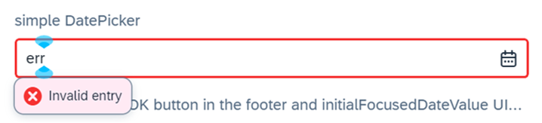

**You are TOAST :)**

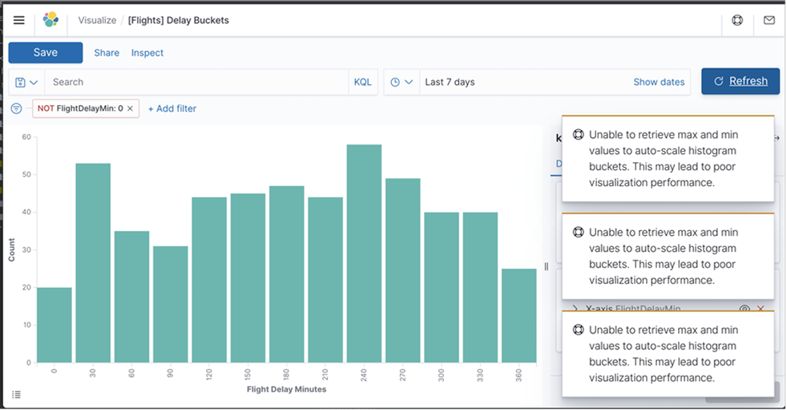

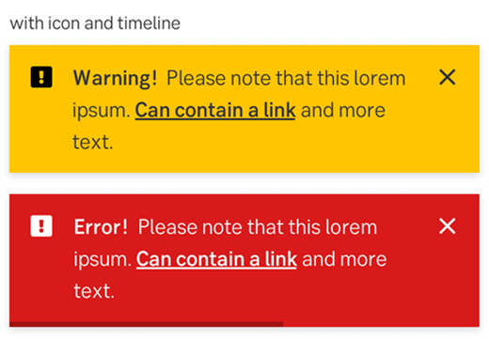

Are these dialogs? Maybe .. but auto vanishing .. and how to access any links within when they are NOT dialogs but tooltips?

Has the rectangular region showing the alert role according to APG some popover nature ??

Dialog role + pattern

* <https://www.w3.org/TR/wai-aria-1.2/#dialog>
* <https://www.w3.org/WAI/ARIA/apg/patterns/alertdialog/>
* <https://www.w3.org/WAI/ARIA/apg/patterns/dialog-modal/>

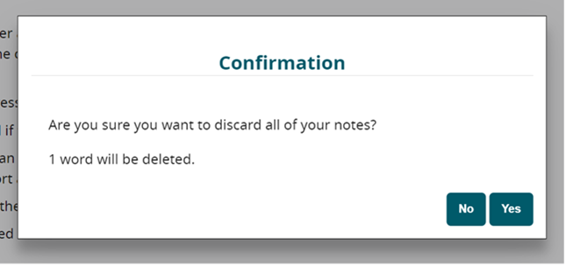

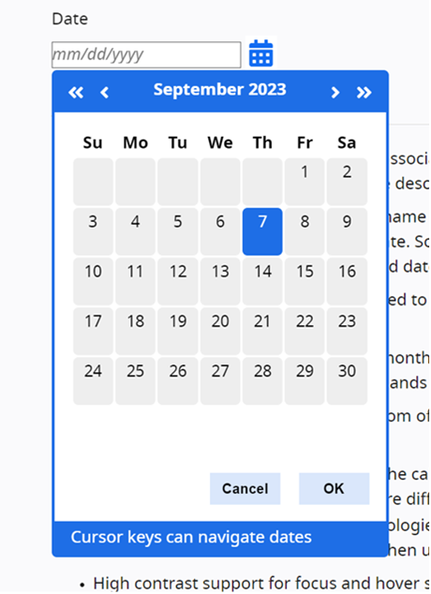

2nd case already illustrates dialog role to be used as a kind of a “popover” variant

Real app builder framework calendar implementations include popup trigger as part of control:

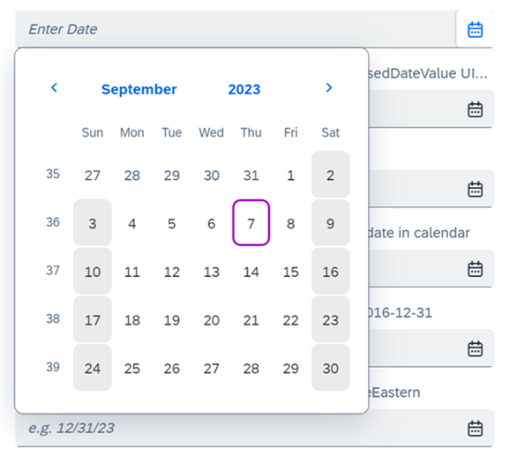

Where does popovers fall in here?

* “Modality” issues:
  + You can click next to calendar popup and it vanishes
  + It is neither modal nor non-modal, it is “ephemeral”
  + “one at a time” dependency - opening one popover closes others
* We could also satisfy the Visual / IXD designer with a popover role that
  + opens on trigger other than hover
  + allows for focus transfer to content
  + avoids modality issues of role dialog

<https://ui5.sap.com/#/entity/sap.m.QuickView/sample/sap.m.sample.QuickView>  
  
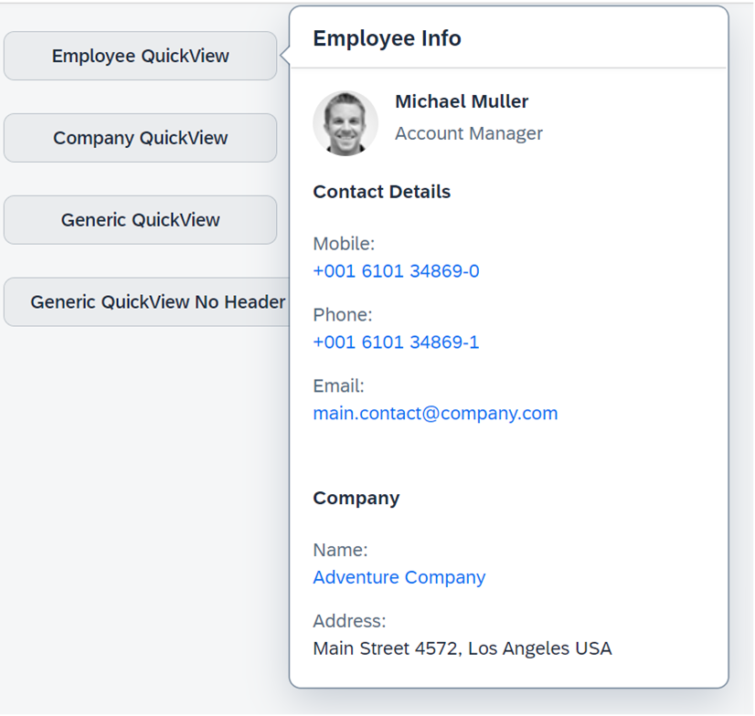

* What “popovers” are NOT:
  + It is NOT a plain DOM container role like a div since it may need labelling and describing in its own right
  + It is not a section element or a region role either since it is a container for these structural roles  
    (you need structural roles inside popups anyway since large popups in industry may contain many interactive elements)

<https://open-ui.org/components/popover.research.explainer/>

* <https://github.com/whatwg/html/issues/6349>
* <https://github.com/whatwg/html/issues/7785>

Open question:

* How to map <https://html.spec.whatwg.org/multipage/popover.html#the-popover-attribute> in ARIA?
* There is role parity but no attribute parity but in this case this HTML attribute implies a role – shouldn’t it be addressed as such in ARIA?
* Implications: Containers with ul lists having ARIA menu role ARE already implicit popovers ! But currently they have no role.  
  <https://www.w3.org/WAI/ARIA/apg/patterns/menu-button/examples/menu-button-actions/>